CSC 4118 - COMPUTER GRAPHICS

Lab Assessment Practice Questions
Basic OpenGL Designs + DDA + Bresenham Line Drawing
Fall 2026-2027 | Student Practice + Instructor Answer Key
Recommended environment | C++ with OpenGL / FreeGLUT
Coordinate system | gluOrtho2D(0, 800, 0, 600)
Suggested duration | 45-60 minutes for selected questions
Purpose | Practice drawing simple scenes and applying line-generation algorithms

Instructions for Students
- Write a complete, compilable OpenGL/FreeGLUT program unless the instructor asks only for the display function.
- Use the design as a guide. Exact colour choice may vary unless a colour is specifically required.
- For DDA/Bresenham questions, do not replace the requested algorithm with GL_LINES.
- Use clear function names and meaningful comments.
- The figures are intentionally simple. Focus on correct primitives, coordinates, and algorithm logic.

Part A - Practice / Lab Assessment Questions
Question 1: Simple House with OpenGL Primitives | 10 Marks
Create the following simple house using basic OpenGL primitives.
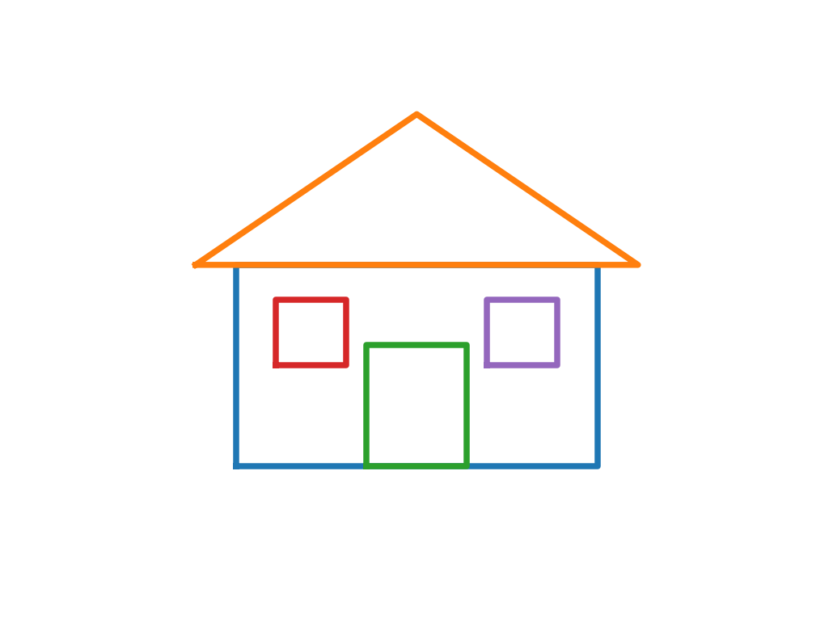
Requirements
- Draw the main house body using GL_QUADS.
- Draw the roof using GL_TRIANGLES.
- Add one door and two windows.
- Use at least three different colours.
- Do not use image files or textures.
Hint: A convenient world window is 0-800 in x and 0-600 in y.

Question 2: Traffic Signal | 10 Marks
Create the traffic signal shown below.
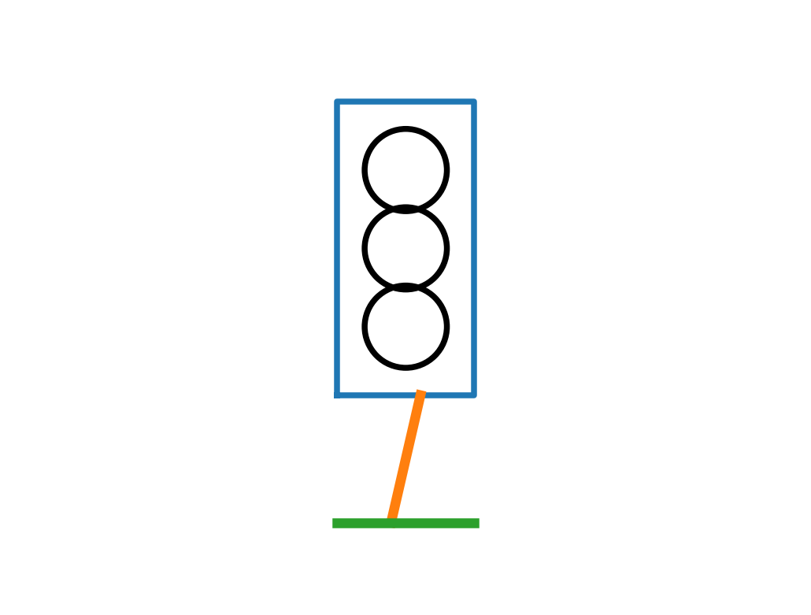
Requirements
- Draw the signal box as a rectangle.
- Draw three circular lights (red, yellow, green).
- Draw a pole and a base.
- Use a helper function to draw a circle using points/polygon vertices.
- Keep the three lights vertically aligned.
Hint: A circle can be approximated using x = cx + r cos(theta), y = cy + r sin(theta).

Question 3: Boat on Water | 10 Marks
Draw a very simple boat scene similar to the figure.
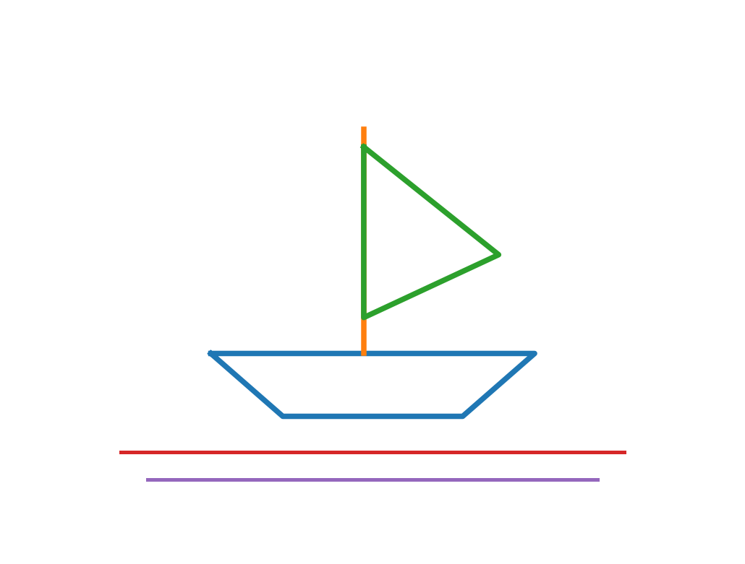
Requirements
- Draw the boat hull using GL_POLYGON or GL_QUADS/triangles.
- Draw a vertical mast.
- Draw one triangular sail.
- Add at least two horizontal water lines.
- Use different colours for the hull, sail and water.

Question 4: Draw the Letter N Using DDA | 15 Marks
Use your own DDA line function to draw the capital letter N. Do not use GL_LINES for the three main strokes.
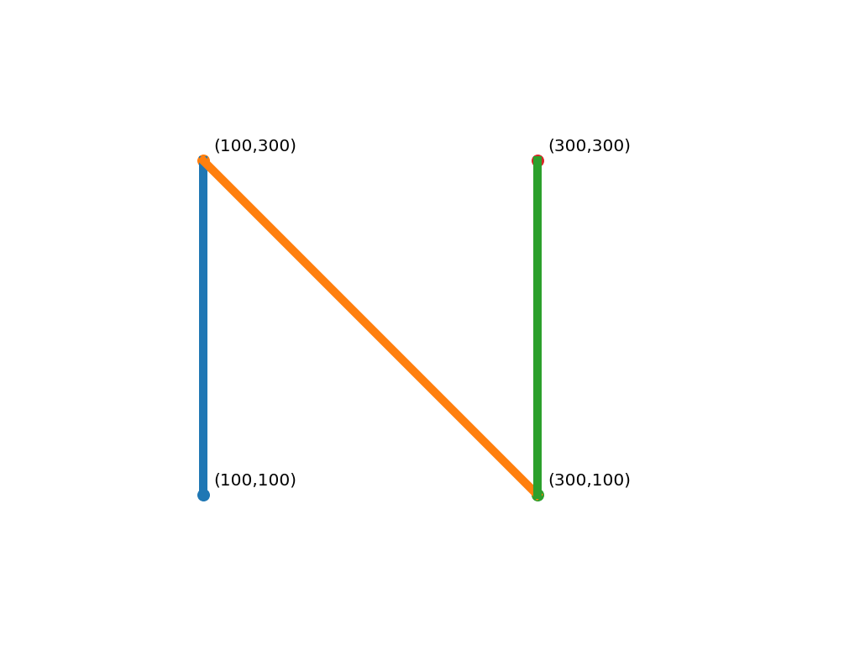
Requirements
- Use these logical coordinates: (100,100) -> (100,300), (100,300) -> (300,100), and (300,100) -> (300,300).
- Implement DDA using dx, dy, steps, xIncrement and yIncrement.
- Plot each generated point using GL_POINTS.
- Show the letter clearly on screen.
Hint: steps = max(|dx|, |dy|).

Question 5: House Outline Using Bresenham | 15 Marks
Draw the outline of a small house using your Bresenham line function only.
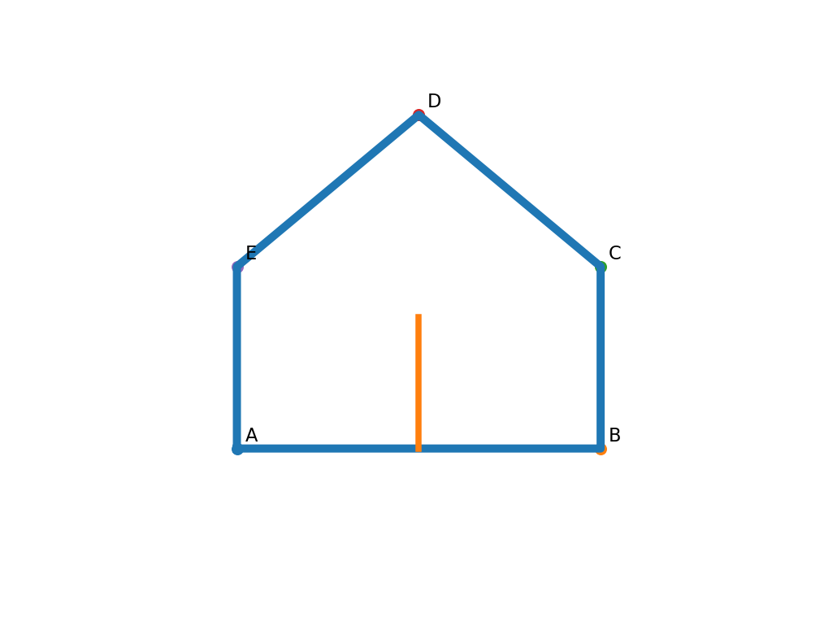
Requirements
- Use separate Bresenham calls for the walls and roof.
- Use integer endpoints.
- Do not use GL_LINES for the outline.
- Add a simple vertical door line if time allows.
- Your Bresenham function should correctly plot every selected pixel.
Hint: For the basic positive-slope version, remember d0 = 2dy - dx when 0 <= m <= 1. A general version may also be used.

Question 6: Kite Using Bresenham Lines | 15 Marks
Draw the kite using Bresenham line segments.
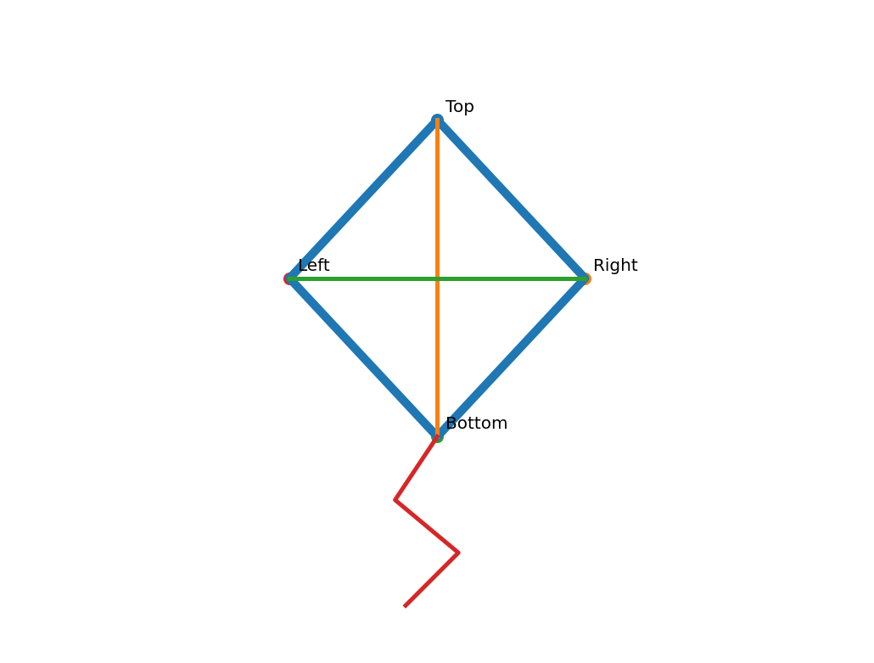
Requirements
- Draw the four outer edges of the diamond.
- Draw the vertical and horizontal internal lines.
- Add a short zig-zag/string using several line segments.
- Use GL_POINTS inside the Bresenham function.
- The shape should remain recognizable even if your exact coordinates differ slightly.

Part B - Instructor Answer Key / Possible Solutions
These are sample solutions. Equivalent programs that satisfy the requirements are also correct.

Common OpenGL Setup (Use with the Answer Snippets)
#include <GL/glut.h>
#include <cmath>
#include <algorithm>
using namespace std;
void init()
{
glClearColor(1.0, 1.0, 1.0, 1.0);
glMatrixMode(GL_PROJECTION);
glLoadIdentity();
gluOrtho2D(0, 800, 0, 600);
}
int main(int argc, char **argv)
{
glutInit(&argc, argv);
glutInitDisplayMode(GLUT_SINGLE | GLUT_RGB);
glutInitWindowSize(800, 600);
glutCreateWindow("CG Lab Practice");
init();
glutDisplayFunc(display);
glutMainLoop();
return 0;
}

Answer 1 - Simple House
void display()
{
glClear(GL_COLOR_BUFFER_BIT);
// House body
glColor3f(0.8f, 0.6f, 0.3f);
glBegin(GL_QUADS);
glVertex2i(220,150); glVertex2i(580,150);
glVertex2i(580,350); glVertex2i(220,350);
glEnd();
// Roof
glColor3f(0.8f, 0.2f, 0.2f);
glBegin(GL_TRIANGLES);
glVertex2i(180,350); glVertex2i(620,350); glVertex2i(400,500);
glEnd();
// Door
glColor3f(0.3f, 0.2f, 0.1f);
glBegin(GL_QUADS);
glVertex2i(350,150); glVertex2i(450,150);
glVertex2i(450,270); glVertex2i(350,270);
glEnd();
// Windows
glColor3f(0.4f, 0.8f, 1.0f);
glBegin(GL_QUADS);
glVertex2i(260,250); glVertex2i(330,250); glVertex2i(330,315); glVertex2i(260,315);
glVertex2i(470,250); glVertex2i(540,250); glVertex2i(540,315); glVertex2i(470,315);
glEnd();
glFlush();
}

Answer 2 - Traffic Signal
const float PI = 3.1415926f;
void circle(float cx, float cy, float r)
{
glBegin(GL_POLYGON);
for (int i = 0; i < 100; i++)
{
float a = 2.0f * PI * i / 100.0f;
glVertex2f(cx + r*cos(a), cy + r*sin(a));
}
glEnd();
}
void display()
{
glClear(GL_COLOR_BUFFER_BIT);
glColor3f(0.15f,0.15f,0.15f);
glBegin(GL_QUADS);
glVertex2i(330,210); glVertex2i(470,210);
glVertex2i(470,510); glVertex2i(330,510);
glEnd();
glColor3f(1,0,0); circle(400,440,40);
glColor3f(1,1,0); circle(400,360,40);
glColor3f(0,1,0); circle(400,280,40);
glColor3f(0.2f,0.2f,0.2f);
glLineWidth(8);
glBegin(GL_LINES);
glVertex2i(400,210); glVertex2i(400,80);
glVertex2i(330,80); glVertex2i(470,80);
glEnd();
glFlush();
}

Answer 3 - Boat on Water
void display()
{
glClear(GL_COLOR_BUFFER_BIT);
// Hull
glColor3f(0.5f,0.25f,0.1f);
glBegin(GL_POLYGON);
glVertex2i(220,220); glVertex2i(580,220);
glVertex2i(500,150); glVertex2i(300,150);
glEnd();
// Mast
glColor3f(0,0,0);
glBegin(GL_LINES);
glVertex2i(390,220); glVertex2i(390,470);
glEnd();
// Sail
glColor3f(0.9f,0.4f,0.2f);
glBegin(GL_TRIANGLES);
glVertex2i(390,450); glVertex2i(390,260); glVertex2i(540,330);
glEnd();
// Water
glColor3f(0.2f,0.5f,1.0f);
glBegin(GL_LINES);
glVertex2i(120,110); glVertex2i(680,110);
glVertex2i(150,80); glVertex2i(650,80);
glEnd();
glFlush();
}

Answer 4 - DDA Letter N
void DDA(float x1, float y1, float x2, float y2)
{
float dx = x2 - x1;
float dy = y2 - y1;
int steps = (int)max(fabs(dx), fabs(dy));
float xInc = dx / steps;
float yInc = dy / steps;
float x = x1, y = y1;
glBegin(GL_POINTS);
for (int i = 0; i <= steps; i++)
{
glVertex2i((int)round(x), (int)round(y));
x += xInc;
y += yInc;
}
glEnd();
}
void display()
{
glClear(GL_COLOR_BUFFER_BIT);
glColor3f(0,0,0);
glPointSize(3);
DDA(100,100,100,300);
DDA(100,300,300,100);
DDA(300,100,300,300);
glFlush();
}

Answer 5 - Bresenham House Outline
void Bresenham(int x1, int y1, int x2, int y2)
{
int dx = abs(x2 - x1);
int dy = abs(y2 - y1);
int sx = (x1 < x2) ? 1 : -1;
int sy = (y1 < y2) ? 1 : -1;
int err = dx - dy;
glBegin(GL_POINTS);
while (true)
{
glVertex2i(x1, y1);
if (x1 == x2 && y1 == y2) break;
int e2 = 2 * err;
if (e2 > -dy) { err -= dy; x1 += sx; }
if (e2 < dx) { err += dx; y1 += sy; }
}
glEnd();
}
void display()
{
glClear(GL_COLOR_BUFFER_BIT);
glColor3f(0,0,0);
glPointSize(3);
Bresenham(220,170,580,170);
Bresenham(580,170,580,350);
Bresenham(580,350,400,500);
Bresenham(400,500,220,350);
Bresenham(220,350,220,170);
Bresenham(400,170,400,300);
glFlush();
}

Answer 6 - Bresenham Kite
void display()
{
glClear(GL_COLOR_BUFFER_BIT);
glColor3f(0,0,0);
glPointSize(3);
// Outer diamond
Bresenham(400,500,540,350);
Bresenham(540,350,400,200);
Bresenham(400,200,260,350);
Bresenham(260,350,400,500);
// Internal lines
Bresenham(400,500,400,200);
Bresenham(260,350,540,350);
// String
Bresenham(400,200,360,140);
Bresenham(360,140,420,90);
Bresenham(420,90,370,40);
glFlush();
}
Note: Use the same general Bresenham function shown in Answer 5.

Short Viva Questions for Practice
- Why is gluOrtho2D useful in beginner 2D graphics programs?
- What is the difference between GL_POINTS, GL_LINES, GL_TRIANGLES and GL_QUADS?
- Why does DDA use steps = max(|dx|, |dy|)?
- Why do we round the plotted DDA coordinates but keep x and y as floating-point running values?
- What is the decision parameter in Bresenham used for?
- Why should GL_LINES not be used to solve a lab task that specifically asks for DDA or Bresenham?

Viva Answer Hints
- gluOrtho2D defines an easy logical 2D coordinate system such as 0-800 by 0-600.
- They tell OpenGL how the supplied vertices should be interpreted: individual points, pairs of line endpoints, groups of three triangle vertices, or groups of four quadrilateral vertices.
- The larger change determines the number of incremental steps so that the dominant coordinate advances by approximately one unit per step.
- The internal DDA value may be fractional; rounding only when plotting avoids repeatedly destroying the accumulated fractional information.
- It tells the algorithm which candidate raster pixel better approximates the ideal line at the next step.
- GL_LINES lets OpenGL rasterize the line internally, while the assessment is intended to test the student's own line-generation algorithm.

